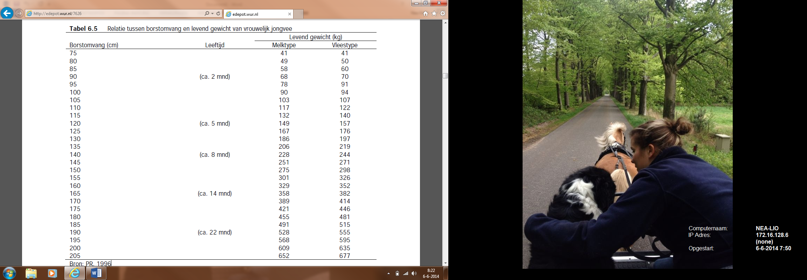

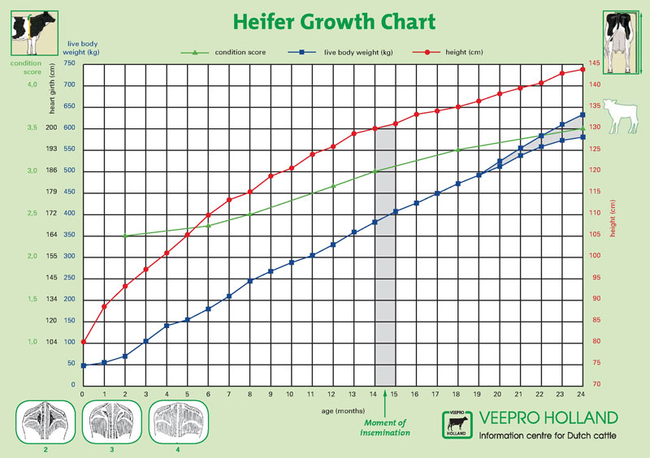

**Tabel Groeiverloop jongvee HF**

|  |  |  |  |  |
| --- | --- | --- | --- | --- |
| **Leeftijd in mnd** | **Gewenste groei g/d** | **Borstomvang**  **cm** | **Hoogtemaat**  **cm** | **Gewicht**  **kg** |
| **0** | 600 | 74 | 86 | 40 |
| **2** | 850 | 94 | 96 | 77 |
| **4** | 900 | 103 | 102 | 128 |
| **6** | 950 | 129 | 107 | 183 |
| **8** | 900 | 143 | 113 | 241 |
| **10** | 825 | 153 | 118 | 296 |
| **12** | 750 | 162 | 122 | 347 |
| **14** | 675 | 170 | 127 | 392 |
| **16** | 625 | 176 | 130 | 433 |
| **18** | 575 | 181 | 134 | 472 |
| **20** | 500 | 186 | 137 | 507 |
| **22** | 400 | 190 | 138 | 537 |
| **24** | 250 | 193 | 140 | 570 |